AIM : Write a program in c to perform traversal of an array

Input: 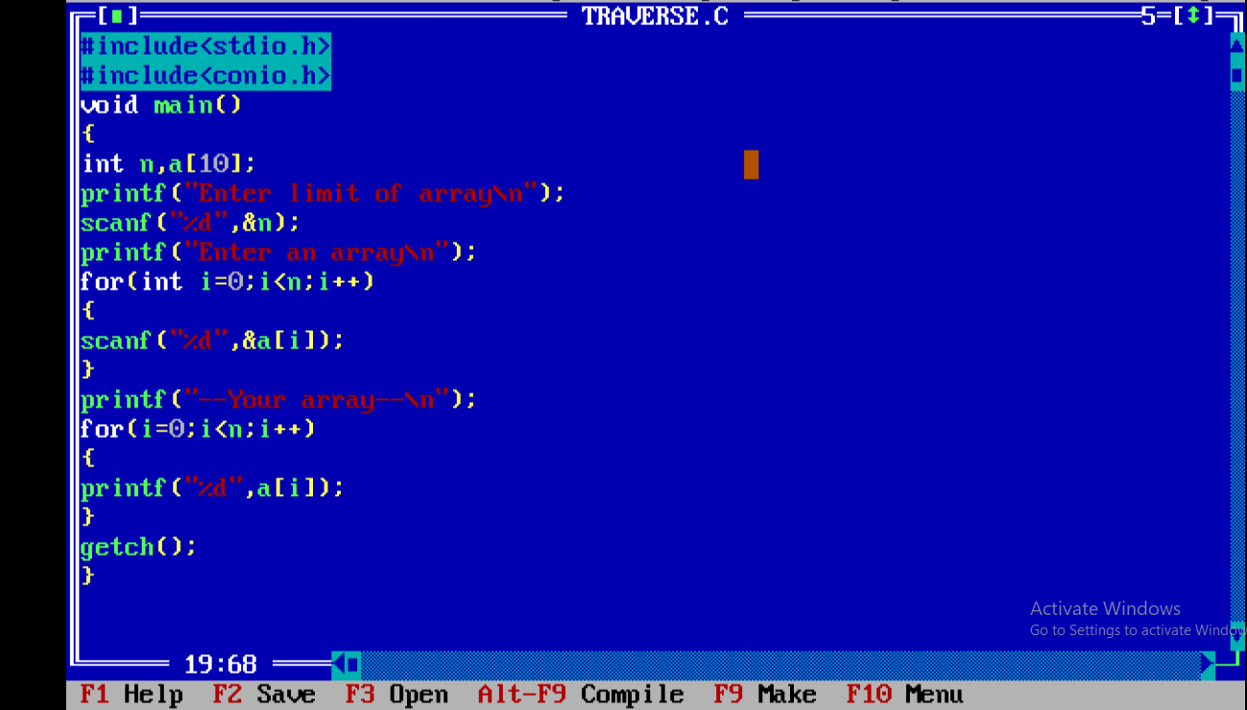

Outut :

